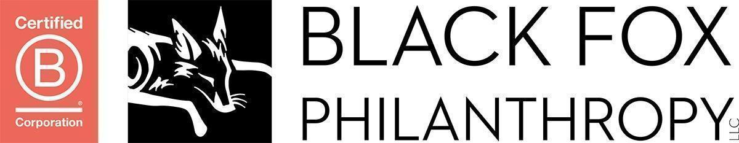
Major Donor Prospect Rating Form
ORG Board Member/Staff Person Name: ________________________________________________

Dominant Fundraising Style: Asker, Nurturer, or Connector. __________________________________

Candidate Name | Relationship | Capacity | Likelihood of Funding | Optimal Approach | Why a strong candidate

Major Donor Prospect Rating Form Key

Use the following key when completing the form above:

Relationship
1 - Close friend or associate
2 - Acquainted and friendly
3 - Met several times
4 - Met once or twice
5 - Never met

Capacity
(Amount you believe this prospect could pledge to ORG)
1 - $500,000 or more over 3 to 5 years
2 - $250,000 or more over 3 to 5 years
3 - $100,000 or more over 3 to 5 years
4 - $50,000 or more over 3 to 5 years
5 - $25,000 or more over 3 to 5 years
6 - $10,000 or more over 3 to 5 years
7 - $5,000 or more over 3 to 5 years
8 - $2,500 or more over 3 to 5 years

Likelihood of Funding
A - High level of interest in ORG
B - Moderate level of interest (probably donates or attends ORG activities)
C - Low level of interest but with potential for cultivation (doesn't give or participate yet but is interested in the mission of ORG)
D - No interest and no concern for ORG

Optimal Approach
1 – I will contact
2 - (Primary fundraiser) or other fundraiser to contact using my name
3 – Other – Please specify

